2025 – Gospel of John – Chapters 7 through 21 - “That we might believe…”
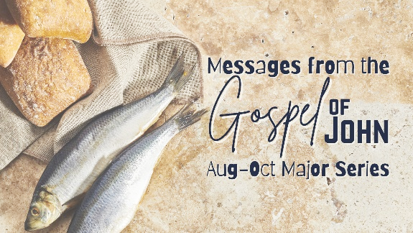
- Continuation from 2024
Part 2: Chapters 7-21
- Bible, listening, watching & sharing
- stirling.elvanto.com.au
- Series booklet
- Audio recordings

Today from Chapter 7 and 8 – “Not on my own”
- Where are we at in the story of the Gospel of John?
- Overview – what people thought and said about Jesus
- Did Jesus lie? (Our struggle with the timing of the Lord)
- Not on my own? (Our humility to be led by the Spirit)

Feast of Tabernacles
- Also known as Feast of Booths and Sukkot.
- The seventh and last feast the Lord commanded Israel to observe.
- Feast of Tabernacles begins and ends with Sabbath rest.
  - Generational and unifying way to remember their deliverance by God.
(Ex 23:16 & De 16:13-16)(Lev 23)(1 Kgs 8:2)(Ezra 3)(Neh 8)
  - AND to look forward to the coming Messiah who would deliver His people
  - 1 of 3 mandatory feasts to “appear before the Lord”.
  - The temple itself was the place for that” appearing”.

Timing and setting of the every increasing sense of conflict
- The Feast could be seen as a natural ‘god-ordained’ mandatory highlight for the religious leaders to build rapport and loyalty with people, and maintain and/or improve status.
- But the heart and attitude of the religious leaders is clearly shown to us in 11:48
“If we let [Jesus] go on like this, everyone will believe in him, and then the Romans will come and take away both our temple and our nation.”
- Therefore: maybe the final celebration and Feast for the year was also the perfect place to exert Temple power, influence &control.
- And Jesus was threatening their control, influence and way of managing the everyday life of the average Jew.
2025 – Gospel of John – Chapters 7 through 21 - “That we might believe…”
- Continuation from 2024
Part 2: Chapters 7-21
- Bible, listening, watching & sharing
- stirling.elvanto.com.au
- Series booklet
- Audio recordings

Today from Chapter 7 and 8 – “Not on my own”
- Where are we at in the story of the Gospel of John?
- Overview – what people thought and said about Jesus
- Did Jesus lie? (Our struggle with the timing of the Lord)
- Not on my own? (Our humility to be led by the Spirit)

Feast of Tabernacles
- Also known as Feast of Booths and Sukkot.
- The seventh and last feast the Lord commanded Israel to observe.
- Feast of Tabernacles begins and ends with Sabbath rest.
  - Generational and unifying way to remember their deliverance by God.
(Ex 23:16 & De 16:13-16)(Lev 23)(1 Kgs 8:2)(Ezra 3)(Neh 8)
  - AND to look forward to the coming Messiah who would deliver His people
  - 1 of 3 mandatory feasts to “appear before the Lord”.
  - The temple itself was the place for that” appearing”.

Timing and setting of the every increasing sense of conflict
- The Feast could be seen as a natural ‘god-ordained’ mandatory highlight for the religious leaders to build rapport and loyalty with people, and maintain and/or improve status.
- But the heart and attitude of the religious leaders is clearly shown to us in 11:48
“If we let [Jesus] go on like this, everyone will believe in him, and then the Romans will come and take away both our temple and our nation.”
- Therefore: maybe the final celebration and Feast for the year was also the perfect place to exert Temple power, influence &control.
- And Jesus was threatening their control, influence and way of managing the everyday life of the average Jew.


